The Linux cd command **offers several ways to navigate and change the working directory using the terminal window**. It lets you change directories using relative and absolute paths, move to parent or root directories, or find directories with incomplete names. Note: The cd command is a built-in shell command

The **cd** command in Linux uses the following syntax:

cd [options] [directory]

In the command above:

* **cd**: Invokes the **cd** command.
* **[options]:** Adding options changes the way the command executes.
* **[directory]**: Path to the directory you want to move into.

For instance, to move to the *Desktop* directory, run:

cd /home/phoenixnap/Desktop

The **cd** command uses the following options:

* **-L**: Force following symbolic links. This option is enabled by default.
* **-P**: Do not follow symbolic links. This option resolves the symbolic link to determine the parent directory before moving to the user-requested directory.
* **-e**: Exit with a non-zero status if using the **-P** option and the command cannot resolve the symbolic link.
* **-@**: Present a file with extended attributes as a directory containing the file attributes.

**Change Directory and List Content**

* Append the **ls** command to the **cd** command using the **&&** flag to change to a new directory and list its content simultaneously.
* cd [path to directory] && ls

### Changing Directory Using an Absolute Path

### Using an absolute path to the directory means that the path starts from the root directory. For instance, changing to the Downloads directory using its absolute path:

cd /home/phoenixnap/Downloads

**Changing Directory Using a Relative Path**

A relative path is a path to a directory relative to the current working directory. A relative path is best used when changing to a subdirectory of the current working directory.

In the example above, the *Downloads* directory is a subdirectory of *Home*. In this case, a relative path is a result of omitting the path to the current directory from the path to the new working directory:

cd Downloads

**Changing to the Root Directory**

Add the slash symbol (**/**) to the **cd** command to move into the system's working directory:

cd /

**Changing Back to the Home Directory**

In Linux, the *Home* directory represents the default working directory. Using the **cd** command without any options or path changes back to the default working directory:

cd

**Changing to Parent Directory**

To change to the parent of the current directory, add two period symbols (**..**) to the **cd** command.

For example, to move from *Example01* to its parent directory *Example_Directory*:

cd ..

**Changing to the Previous Directory**

Adding a dash symbol (**-**) to the **cd** command returns the shell to the previous working directory. For instance, after moving from *Downloads* to *Example_Directory*, return to *Downloads* with:

cd -

**Changing to Another User's Home Directory**

Change to another user's *Home* directory by adding the tilde symbol (**~**) appended with the appropriate username.

cd ~[username]

For instance, changing to the *Home* directory of a user named *alex*:

cd ~alex

[Home](https://phoenixnap.com/kb/) » [SysAdmin](https://phoenixnap.com/kb/category/sysadmin) » How to Use the Linux cd Command to Change Directory

Introduction

Many [Linux commands](https://phoenixnap.com/kb/linux-commands), such as the [ls command](https://phoenixnap.com/kb/linux-ls-commands), affect the current [working directory](https://phoenixnap.com/glossary/what-is-a-directory). The current working directory is the directory your terminal window or command prompt is working in.

Linux treats the Home directory as the default working directory. Using the **cd** command in Linux allows you to change the current working directory.

**In this tutorial, we will explain the cd command syntax and show examples of how you can use it.**

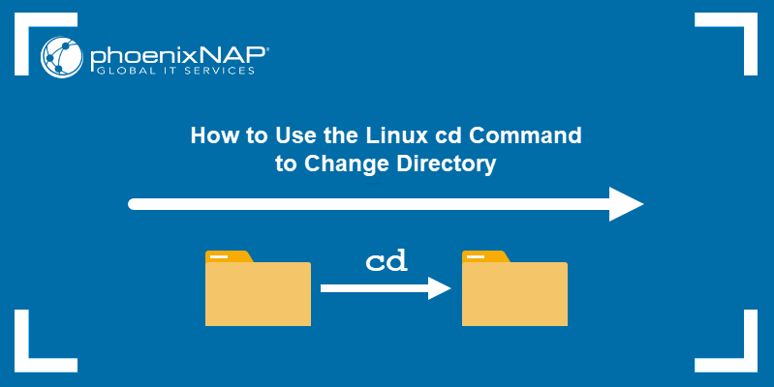

Prerequisites

* A system running a Linux distribution.
* A user account with [sudo privileges](https://phoenixnap.com/kb/linux-sudo-command).
* Access to the terminal window or command line.

## Linux CD Command Syntax

The **cd** command in Linux uses the following syntax:

cd [options] [directory]

In the command above:

* **cd**: Invokes the **cd** command.
* **[options]:** Adding options changes the way the command executes.
* **[directory]**: Path to the directory you want to move into.

For instance, to move to the Desktop directory, run:

cd /home/phoenixnap/Desktop

If the command executes successfully, the current working directory is indicated in the terminal interface:

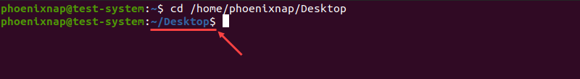

If the terminal interface does not indicate the current working directory, using the **pwd** command displays it as the output:

pwd

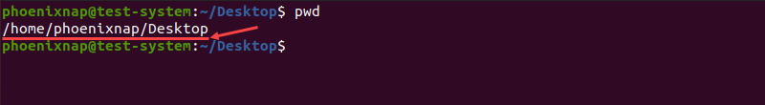

The **cd** command uses the following options:

* **-L**: Force following symbolic links. This option is enabled by default.
* **-P**: Do not follow symbolic links. This option resolves the symbolic link to determine the parent directory before moving to the user-requested directory.
* **-e**: Exit with a non-zero status if using the **-P** option and the command cannot resolve the symbolic link.
* **-@**: Present a file with extended attributes as a directory containing the file attributes.

## How to use Linux CD Command

The Linux **cd** command offers several ways to navigate and change the working directory using the terminal window. It lets you change directories using relative and absolute paths, move to parent or root directories, or find directories with incomplete names.

**Note:** The **cd** command is a built-in shell command. This means that its behavior varies slightly between shells since it uses shell environment variables. Learn more in our [guide to environment variables in Linux](https://phoenixnap.com/kb/linux-set-environment-variable).

### Changing Directory

To change to a new working directory, use the **cd** command with a directory path.

cd [path to directory]

For instance, moving to Example_Directory, located in the Home directory:

cd Example_Directory



### Change Directory and List Content

Append the **ls** command to the **cd** command using the **&&** flag to change to a new directory and list its content simultaneously.

cd [path to directory] && ls

Using the previous example:

cd Example_Directory && ls

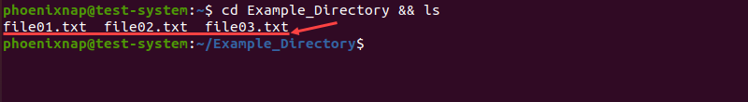

**Note:** Add [ls command options](https://phoenixnap.com/kb/linux-ls-commands) to change the way directory contents are displayed.

### Changing Directory Using an Absolute Path

Using an absolute path to the directory means that the path starts from the root directory. For instance, changing to the Downloads directory using its absolute path:

cd /home/phoenixnap/Downloads



### Changing Directory Using a Relative Path

A relative path is a path to a directory relative to the current working directory. A relative path is best used when changing to a subdirectory of the current working directory.

In the example above, the Downloads directory is a subdirectory of Home. In this case, a relative path is a result of omitting the path to the current directory from the path to the new working directory:

cd Downloads

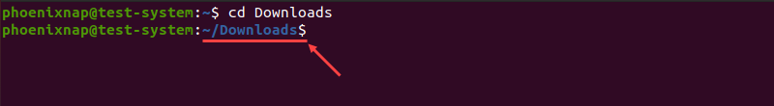

Since the path to the current directory is /home/phoenixnap, omitting that part of the absolute path to the Downloads directory (/home/phoenixnap/Downloads) results in a relative path (Downloads).

### Changing to the Previous Directory

Adding a dash symbol (**-**) to the **cd** command returns the shell to the previous working directory. For instance, after moving from Downloads to Example_Directory, return to Downloads with:

cd -



### Changing to Parent Directory

To change to the parent of the current directory, add two period symbols (**..**) to the **cd** command.

For example, to move from Example01 to its parent directory Example_Directory:

cd ..



### Changing to the Root Directory

Add the slash symbol (**/**) to the **cd** command to move into the system's working directory:

cd /



### Changing Back to the Home Directory

In Linux, the Home directory represents the default working directory. Using the **cd** command without any options or path changes back to the default working directory:

cd

The absence of the current working directory path indicates that you are in the default working directory:



Another way to do this is to add the tilde symbol (**~**) to the **cd** command:

cd ~

### Changing to Another User's Home Directory

Change to another user's Home directory by adding the tilde symbol (**~**) appended with the appropriate username.

cd ~[username]

For instance, changing to the Home directory of a user named alex:

cd ~alex



### Changing to a Directory with Spaces in the Name

If the directory name contains blank spaces, change to it by surrounding the name with single quotation marks (**' '**). Alternatively, append a backslash symbol (**\**) to every word in the name except the last one:

cd 'Directory name with blank spaces'

cd Directory\ name\ with\ blank\ spaces

For example, changing to a directory named This is a directory:

cd 'This is a directory'

cd This\ is\ a\ directory

### Autocomplete Directory Name

If you don't know the name of the directory you are trying to move to, the Linux terminal offers an autocomplete feature. After you start typing the directory name, press the **Tab** button on your keyboard to get autocomplete suggestions.

For instance, if you know that the name of the directory starts with an **X** (for instance, XYZ), type:

cd X[Tab]